🚀 Android Developer Bootcamp

Student Profile Page

Workshop #03

🎯 Purpose
This workshop focuses on mastering ConstraintLayout in Android XML design.
You will learn how to build a structured profile UI using proper constraints, relationships between views, and responsive positioning.

🧩 Problem
Design a Student Profile Page UI using ConstraintLayout only as the root layout.
Your main goal is to correctly implement view relationships using constraints instead of simple stacking.

📌 UI Content

👤 Student Profile Section
Display the following details:
- Name → Aparna
- Bio → Android Learner
👉 These must be positioned using ConstraintLayout relationships (not default positioning)

📊 Stats Section (Important Update)
Create a horizontal card showing:
- Posts → 10
- Followers → 250
- Following → 180
👉 Each item must be equally distributed in a single row using LinearLayout inside ConstraintLayout.

⚠️ 🔥 IMPORTANT CHANGE (Constraint Challenge)
To improve understanding of ConstraintLayout relationships:

❌ REMOVE this field completely:
👉 Bio field should NOT be directly placed below Name using simple stacking

✅ INSTEAD:
You must use ConstraintLayout logic such that:
- Name is centered below the header area
- Bio must be positioned using a different constraint relationship (not direct top-to-bottom chaining)
- Example idea: Bio should be constrained relative to the stats card or parent layout, not directly under Name
👉 This forces students to understand ConstraintLayout dependency structure

📚 Actions Section
Below stats, add a button:
- FOLLOW
👉 Must be centered horizontally using ConstraintLayout constraints.

📖 About Section
Add a card below the button:
- Title: About
- Description:
“Simple Android profile UI built using ConstraintLayout. Clean, minimal and modern design.”

🧱 How to Solve
- Use ConstraintLayout as root layout
- Do NOT rely on simple vertical stacking
- Use proper constraints between views
- Ensure at least one view uses non-linear dependency (important requirement)
- Use LinearLayout only inside stats card
- Ensure proper spacing and alignment

🎯 Learning Outcomes
After completing this workshop, you will understand:
- How ConstraintLayout manages view relationships
- How to avoid linear stacking dependency
- How to design responsive UI using constraints
- How to position elements using parent + sibling references
- How real Android UI structures are built
📸 Screenshots
Before Implementation
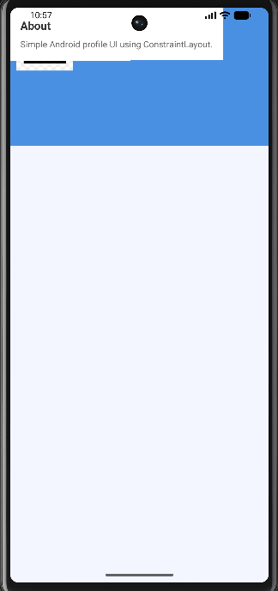
After Implementation
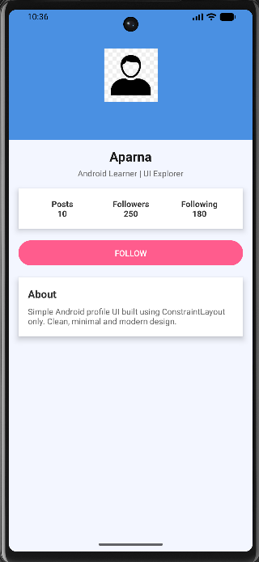

🚀 How to Submit Your Workshop
Push your project back to the same Git branch using:
git add .
git commit -m "Completed Student Profile Page Workshop"
git push origin <user-branch>

🚀 Happy Coding! 🎨📱
窗体顶端
窗体底端

